VMware installation

1.Downloaded the softwares.zip file
2. Extracted the softwares.zip file.
3. Opened the extracted folder.
4. Double-clicked on the VMware installation file.
5. Followed the installation steps as per the provided SOP

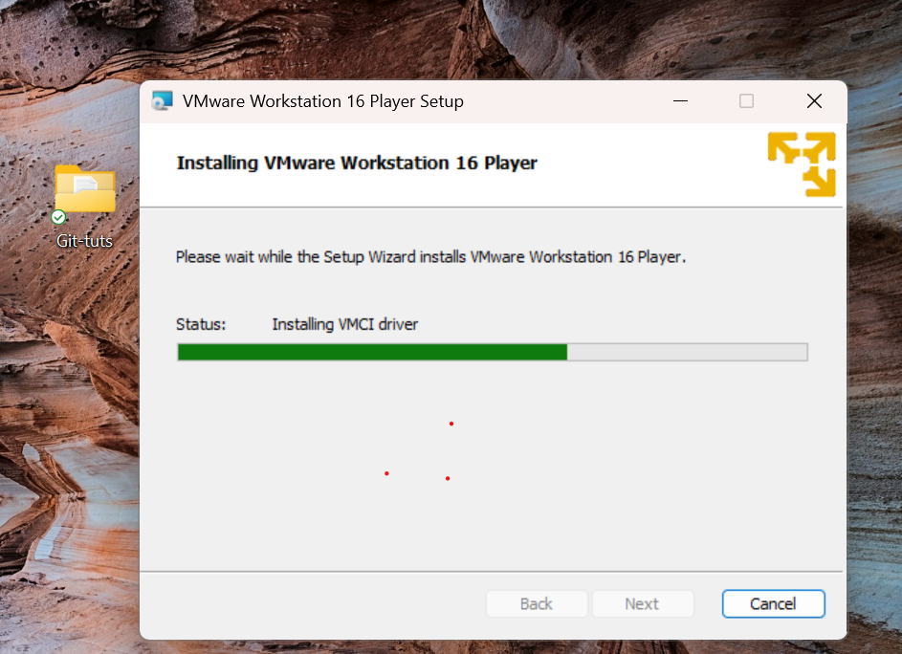

6.Completed the VMware installation successfully.

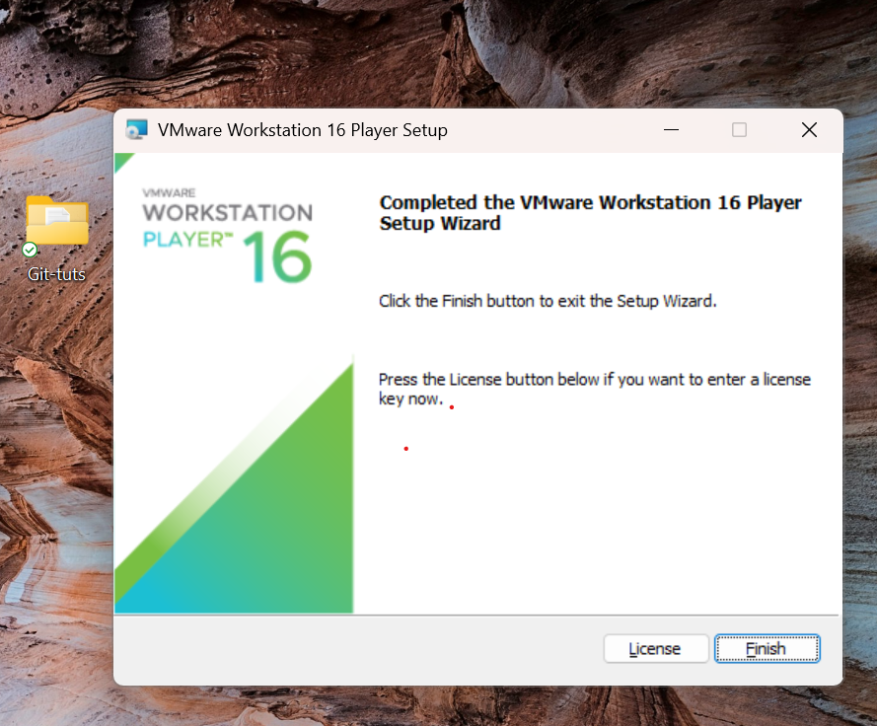

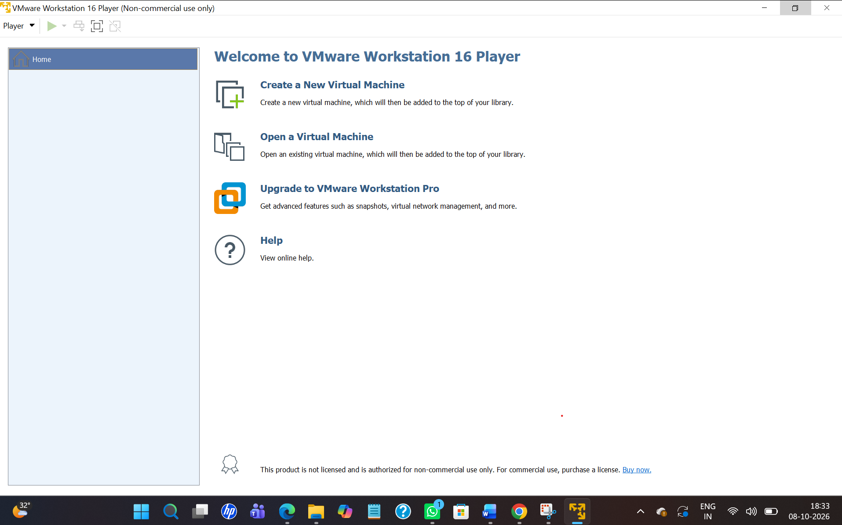

7.Selected the option to create a New Virtual Machine.
8.Selected the provided Ubuntu OS image/file for the virtual machine.

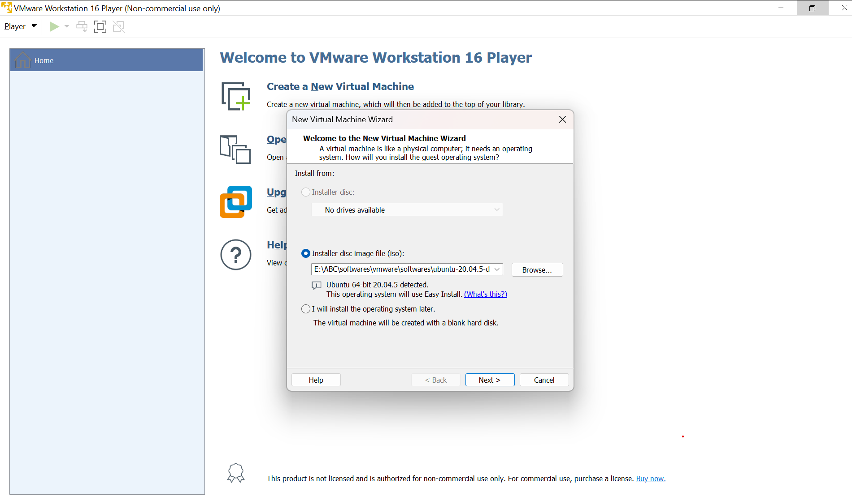


9.Executed the following command to update the packages and to install the required packages information:
sudo apt-get update
sudo apt-get install -y openssh-server net-tools
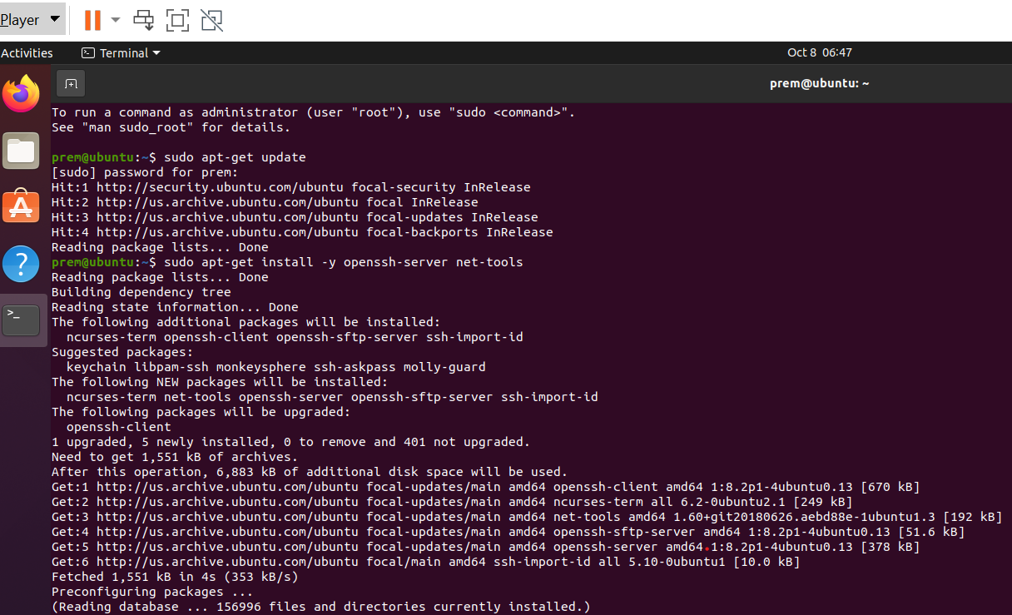

10.Executed the following command to check the network configuration and IP address of the Ubuntu VM:
ifconfig
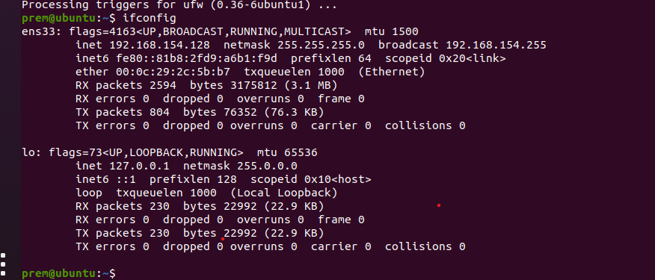

11. Connected successfully to the Ubuntu VM remotely using MobaXterm.

